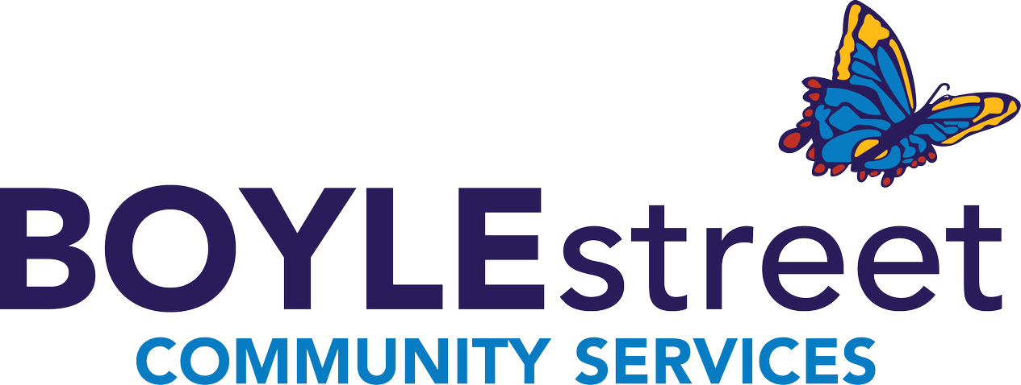
PRACTICUM STUDENT APPLICATION
Thank you for your interest in completing your student placement with Boyle Street Community Services! Please use this form to tell us about yourself so we can find a placement that works best for you and our community.
You must submit your program requirements with this document to be considered for a placement. Thank you.

PERSONAL INFORMATION APPLICATION DATE:
Desired position:
Last Name |  | Given Names: |  |  |  | Pronouns:
Address |  |  | City | Province |  |  | Postal Code
Email: |  |  | Birthdate: |  | Cell:
Available start date: | Available Days & times (between Monday to Friday 9:00am – 4:00pm):
My placement length will be ____________ hours/months
How did you hear about us? If you were referred by a staff member please include their name.
Boyle street website social media word of mouth friends/family ambassador
program staff __________________ Other _______________________

SUITABILITY
Please tell us why you have chosen Boyle Street Community Services as well as any relevant experience

LEARNING OBJECTIVES & STUDENT ACTION PLAN
Learning Objectives: What you would like to learn and gain during this practicum? | Learning Activity: How will you meet and complete these learning objectives? | Evaluation: How will you know you have completed the activities, and how will you know the learning objective has been reached?

PROGRAM CONTACT
Name |  | Program & Institute
Email Address | Phone number

REFERENCE
Name |  | Relationship
Email Address | Phone number |  | Years Known

DECLARATION OF APPLICANT
Read Carefully Before Signing
I CONFIRM that the information given on this application is true to the best of my knowledge. I understand that any untrue statement may be grounds for dismissal.
I WILL provide the following if I am offered a student placement:
- Criminal Record Check with Vulnerable Sector Check
- Child Intervention Record Check
I AUTHORIZE the Boyle Street Community Services to conduct checks of my qualification and references as may be necessary.
I UNDERSTAND that submitting this application does not guarantee my acceptance and I agree to participate in further screening to assist Boyle Street Community Services in determining my suitability for a student placement.
I UNDERSTAND that appointment to any position at Boyle Street Community Services is dependent upon the results of reference and record checks.
I ACKNOWLEDGE that all facilities operated by Boyle Street Community Services are non-smoking and that I will not be permitted to smoke while working on Boyle Street Community Services Property.

___________________________ __________________
Signature

_____________________________________________
Date

Please send this completed application along with your cover letter and resume to: Students@boylestreet.org

